**Amazon Relational Database Service**

**If need a database as a service Amazon is providing RDS**

**AWS RDS makes it easy to set up, manage, and scale a relational database in the cloud.**

**This service provides cost-effective and customizable capabilities and automates time-consuming administrative tasks such as hardware delivery, database setup, patch scanning, and backups.**

**So the user,**

**No need to use the hardware.**

**No need to install and manage the database.**

**No need to apply the patch for the database.**

**No need to take backup for the database regularly.**

**These all can be done automatically by using the AWS RDS service.**

1. **RDS supports 6 types of databases:**
2. **Amazon Arora**
3. **PostgreSQL**
4. **MySQL**
5. **Oracle Database**
6. **Microsoft**

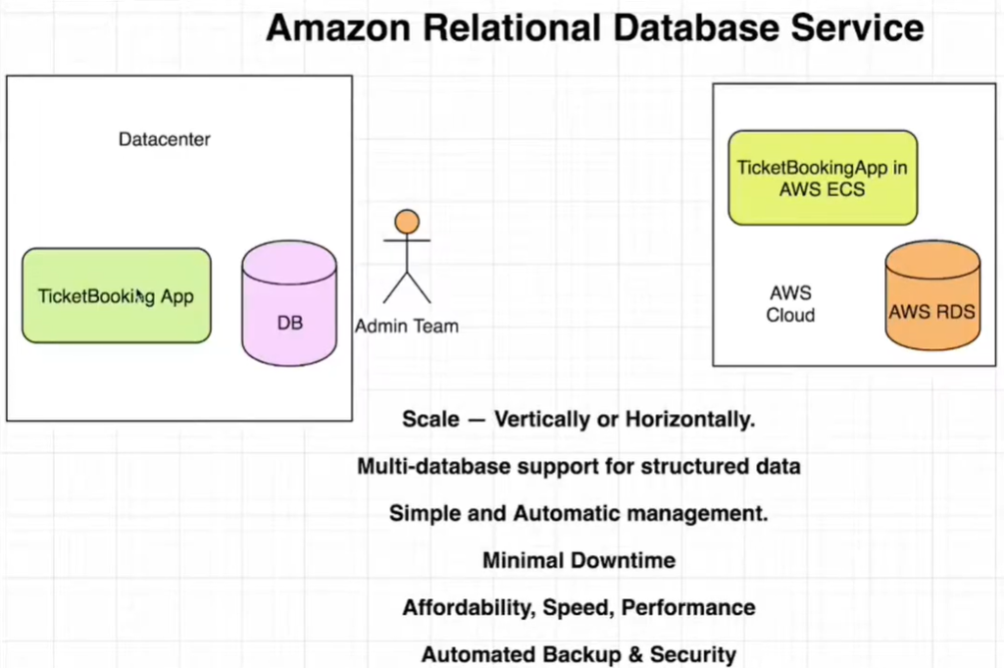

**Benefits of moving in to AWS RDS service:**

1. **Scale – Vertically or Horizontally**
2. **Multi-database support for structured data**
3. **Simple and Automatic management**
4. **Minimal Downtime**
5. **Affordability, Speed, Performance**
6. **Automated Backup & Security.**

**Demo – How to Create AWS RDS.**

**Steps:**

1. **Click on to RDS from the Database section in the amazon console.**

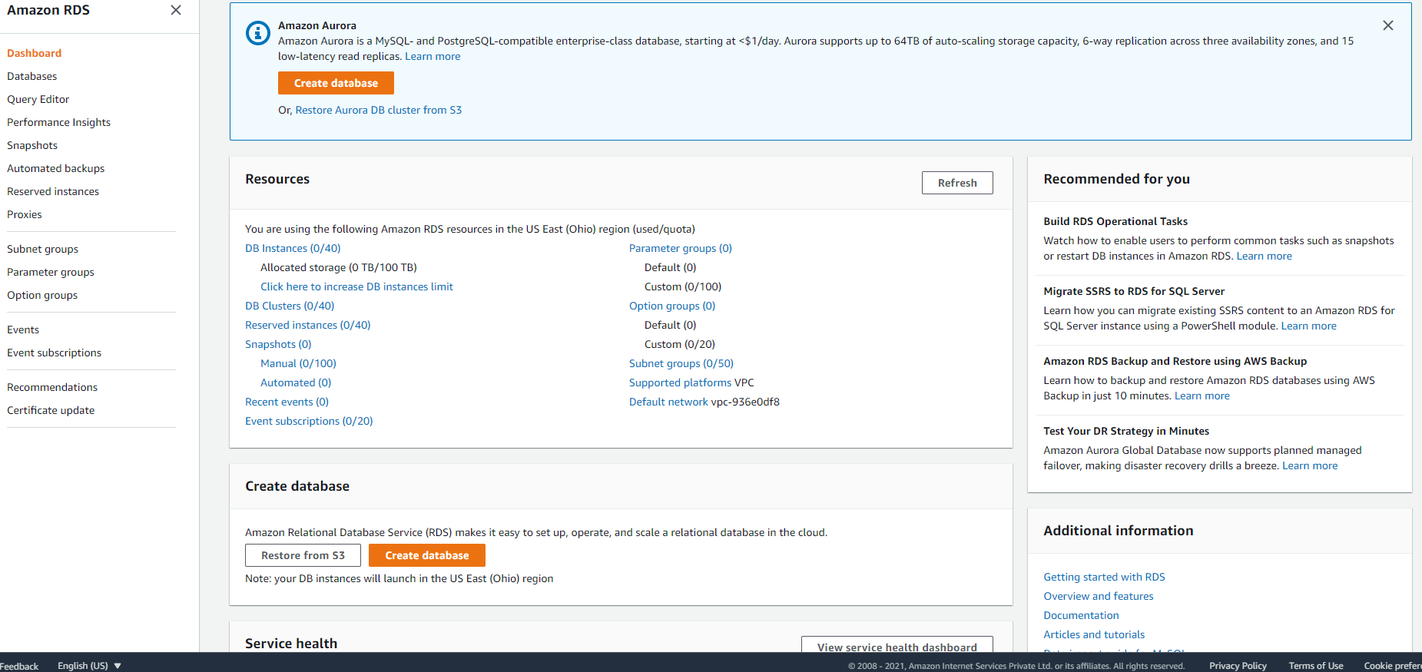

1. **Click on Create Database:**

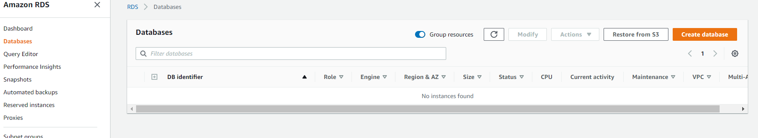

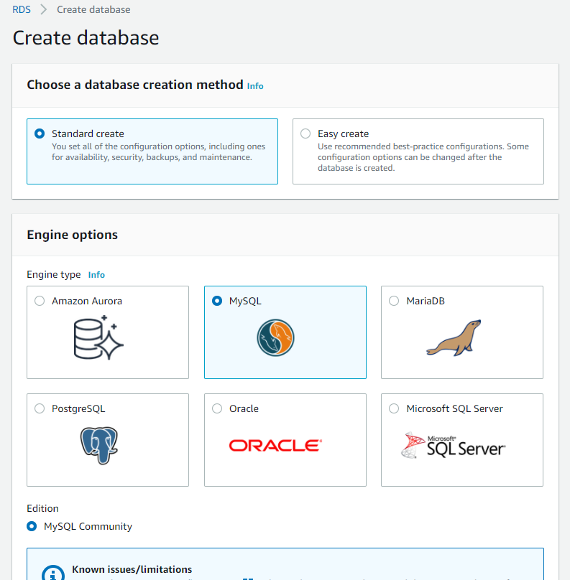

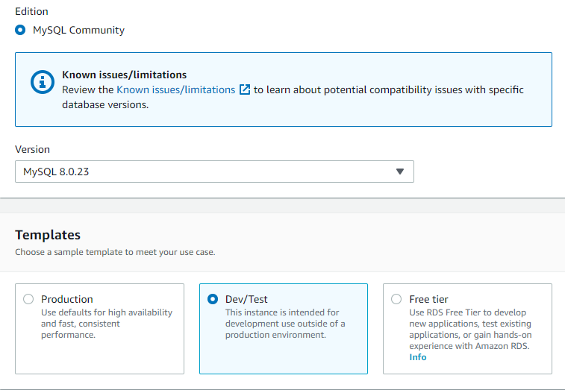

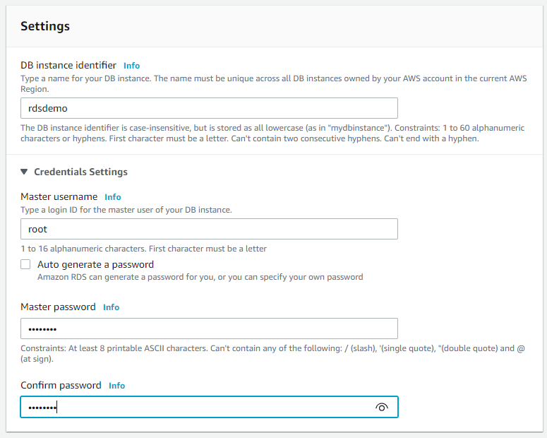

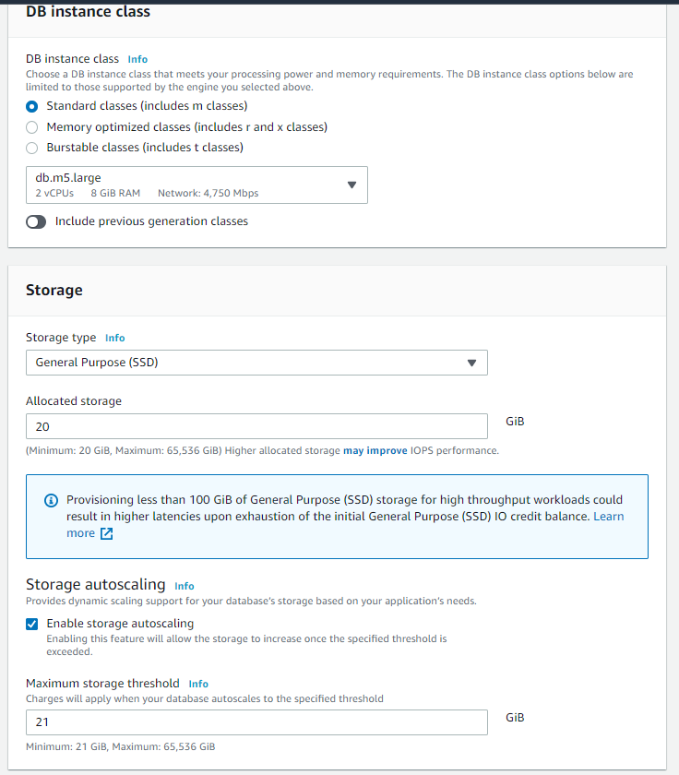

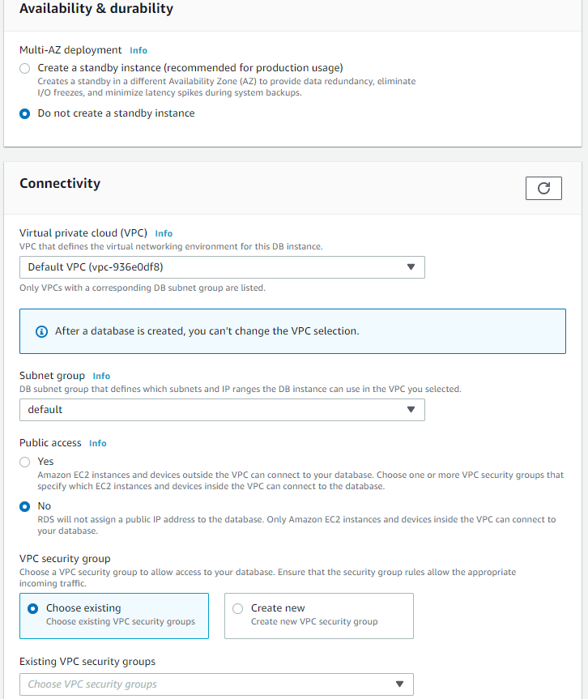

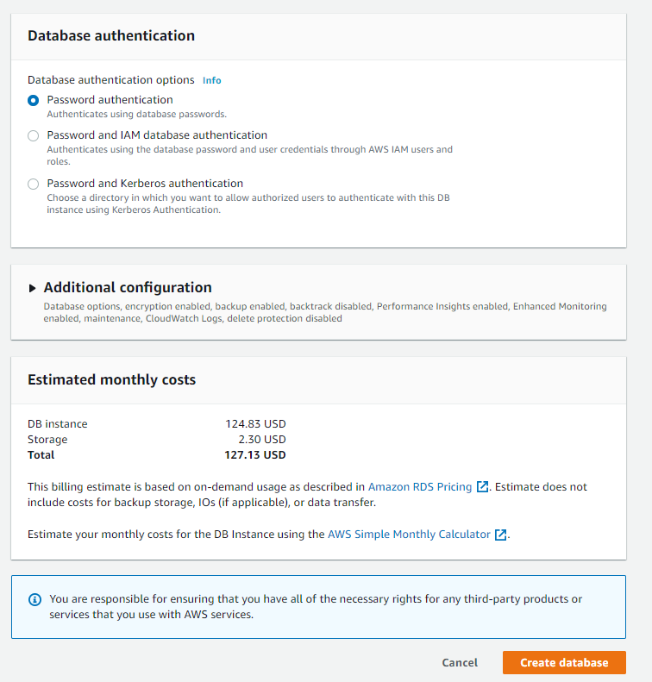

**Successfully Created:**

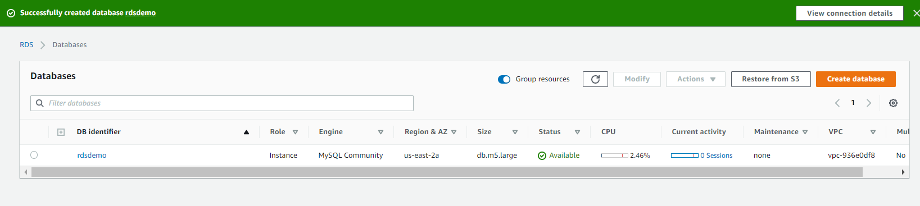

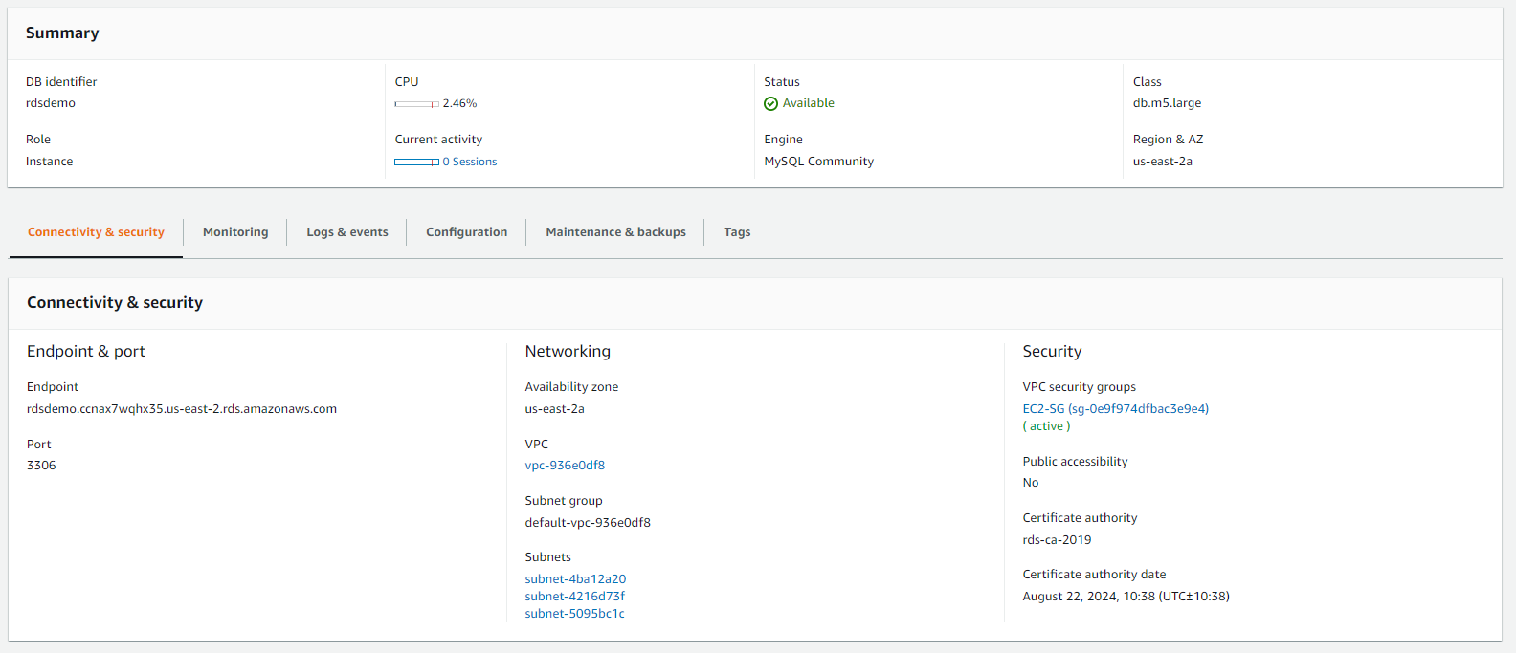

**Copy the endpoint and paste it on command prompt:**

**Open the cmd**

**Install MySQL in your local machine for the environmental set up, then only the cmd will accept the MySQL commands.**

**Type: mysql -h** rdsdemo.ccnax7wqhx35.us-east-2.rds.amazonaws.com –port=3306 -u root -p

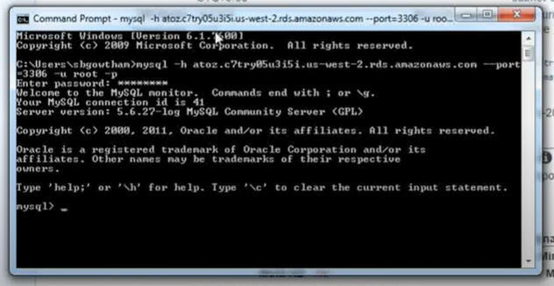

**Type: show database**

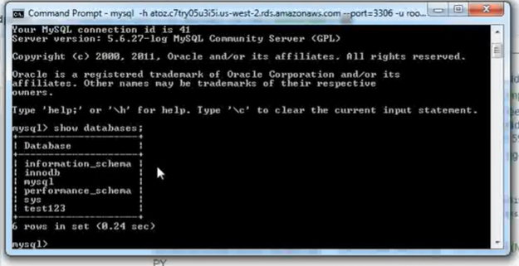

**To use the database:**

**Type: use database**

